**Project Title**

**Market Risk Analysis of Tesla Stock using Historical and Monte Carlo Simulation Methods**

**1. Objective / Problem Statement**

The selected risk type for this study is Market Risk, which measures the possibility of losses in Tesla’s stock prices due to fluctuations in the financial markets. The objective of this project is to estimate Value-at-Risk (VaR) and Conditional Value-at-Risk (CVaR) for Tesla’s stock using two approaches:

1. Historical Simulation Method
2. Monte Carlo Simulation Method

**2.Dataset Used**

* The dataset consists of 1 year of historical stock price data of Tesla Inc., collected from Investing.com.
* The dataset contains daily closing prices, which were used to compute daily returns for risk analysis.
* This data reflects actual market performance and was used as the basis for both the Historical Simulation Method and the Monte Carlo Simulation Method.

**3. Methodology**

**A. Historical Simulation Method**

* Calculated daily returns from Tesla stock prices.
* Sorted returns from worst to best.
* Identified percentile losses at confidence levels (90%, 95%, 99%, and 100%).

**B. Monte Carlo Simulation Method**

* Estimated mean and standard deviation of Tesla’s daily returns.
* Simulated thousands of random return scenarios using these parameters.
* Built a simulated distribution of returns.
* Computed VaR and CVaR at the same confidence levels.

**4. Results**

**Historical Simulation Method**

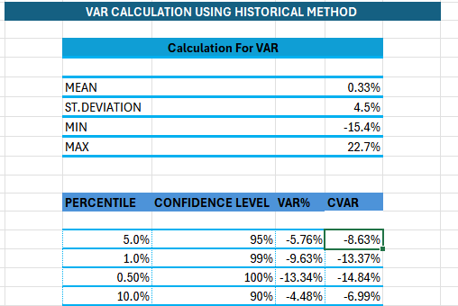

* Mean Return (0.33%) → On average, Tesla stock gave a very small positive return daily.
* Standard Deviation (4.5%) → The stock prices move up and down a lot, showing high volatility.
* 95% VaR = –5.76% → In 95 out of 100 days, loss will not be more than 5.76%. Only 5 out of 100 days can be worse than this.
* 99% VaR = –9.63% → In 99 out of 100 days, loss will not be more than 9.63%. But there is 1% chance losses can be worse.
* CVaR (–8.63% at 95%) → If things go worse than 95% limit, then the average loss will be around –8.63%.

Historical method is showing how Tesla behaved in the past. It catches real crashes or shocks from history. That’s why it sometimes shows bigger risks.

**Monte Carlo Simulation Method:**

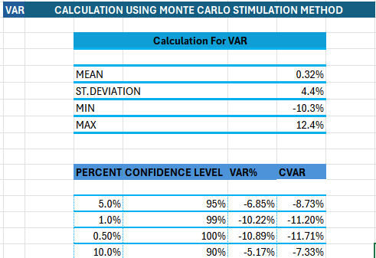

* Mean Return (0.10%) → Again, very small average gain per day.
* Standard Deviation (4.4%) → Similar high volatility as history.
* 95% VaR = –7.08% → In 95% of cases, the loss will not cross –7.08%.
* 99% VaR = –9.88% → In 99% of cases, the loss will not cross –9.88%.
* CVaR (–8.82% at 95%) → If market goes bad beyond the 95%-mark, average loss will be –8.82%.

Monte Carlo is based on simulations (computer-generated scenarios). It does not depend only on past events but uses probability models. That’s why it gives a smoother estimate of risk.

**5.Key Comparison:**

* **Historical Method**:  
  This method looks only at past data. It directly checks what big losses happened before. That’s why it can sometimes show very large or extreme losses.
* **Monte Carlo Method**:  
  This method creates many random future scenarios using a computer. It does not only rely on past data but also on simulations. Because of this, its results are smoother and based on probability.

**Overall Result**

* Both methods show that Tesla’s stock is risky.
* In extreme situations, the stock can fall by around 9% or more in a single day.
* This means that if the market goes badly, investors can face heavy losses.

**6.Key Learnings**

1. Learned how to apply both Historical and Monte Carlo methods for risk measurement.
2. Understood that Value-at-Risk (VaR) is the maximum expected loss for a given confidence level.
3. Understood that Conditional Value-at-Risk (CVaR) shows the *average loss* when losses go beyond the VaR limit.
4. Realized that Tesla stock is very volatile, which makes risk management important.
5. Saw the difference: Historical captures real past shocks, while Monte Carlo gives probability-based predictions.